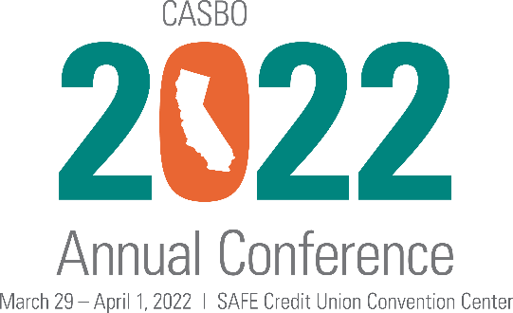

Dear [Name],

I’m seeking permission to attend the CASBO 2022 Annual Conference & California School Business Expo, a conference and marketplace event that will provide innovative strategies to not only help me thrive in the current education environment, but help our organization move beyond disruption to designing solutions that will benefit the students, families and communities we serve.

CASBO 2022 is our three-day headquarters for leadership and networking activities that are at the heart of CASBO professional development. Its visionary thinking will guide us in embracing today’s complexities, and the purposeful learning offered will help us create a dynamic organizational infrastructure.

CASBO 2022 will be held in Sacramento and includes more than 150 sessions on the most critical topics for school business professionals. I’m specifically excited about walking away with ideas on how to [insert your interest here] and learning about these specific areas: [insert topics here].
[If you would like to include the CASBO 2022 program, you may link, download or print it here: https://www.casbo.org/learn-grow/events/annual-conference/]
The registration fee includes attendance at all workshops, general sessions, and networking and social events. It also provides unrestricted access to the California School Business Expo, where I can connect directly with CASBO associate members and partners to see their latest products and services, as well as get their best practices and solutions to the issues facing school business leaders in today’s environment.

Thank you for considering my request to participate in CASBO 2022. It’s a valuable professional development opportunity that will help us acquire innovative strategies for our school business operations!

Sincerely,

[Name and signature]

